**Finfish Task Force Meeting**

**Wednesday, March 15, 2023, 10:00am**

**LDWF Headquarters**

**2000 Quail Drive**

**Baton Rouge, LA 70808**

**I.** Pledge of Allegiance

**II.** Roll call and introduction of guests

**Voting Members Present:**

James Pelas

Acy Cooper, III

Daniel Edgar

Stuart Billeaud

Ben Graham

George Huye

Steve Rockwieler

**Voting Members Absent:**

Wayne Rollo

Daryl Simon

Jay Trotter

Adam Guillory

**Non-Voting Members Present:**

Jason Adriance

Edward Skena

Jack Isaacs

Gene Cavalier

**Non-Voting Members Absent:**

Justin Gremillion

**III.** Steve Rockwieler motioned to approve the December 7, 2022 meeting minutes, 2nd by Daniel Edgar. Motion carries.

**IV.** GeorgeHuyemotioned to approve the March 15, 2023 meeting agenda, 2nd by Daniel Edgar. Motion carries.

**V.** New Business

1. Jason Adriance provided an update on spotted seatrout proposed rule oversight hearing and next steps
2. Jason Adriance provided an update on the upcoming recreational season for greater amberjack and potential increase in the red snapper allocation

Jason Adriance stated that NOAA informed LDWF late last year/ earlier this year that there will be a closure for the May recreational greater amberjack season, the recreational season will not reopen until August 1, when NOAA will track the landings at that point, this is all an effort to reduce overfishing in the stock, there have been some adjustments to the annual catch for greater amberjack, both commercial and recreational, that will likely impact the 2023/24 season, but we do not know how much yet.

Red Snapper update- the 2022 season was 62 days, opened on weekend only, 3 fish season, closed September 18 reopened for another 7 days in October because we had about 40,000 pounds left, reopened daily at 4 fish and ended up with about 2300 pounds over, so that amount will be deducted from next year’s season. NOAA has published some revised state allocations based on new allowable catch that came out of the Gulf Council SSC and that should give us about 122,000 more pounds for next year, so we will be fishing until about 932,000 pounds. LDWF Commission will take this season up at their April 2023 meeting

1. Brian Lezina provided an update on the Mid-Barataria Sediment Diversion

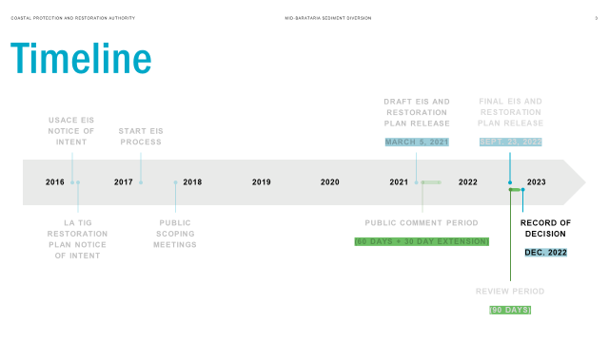

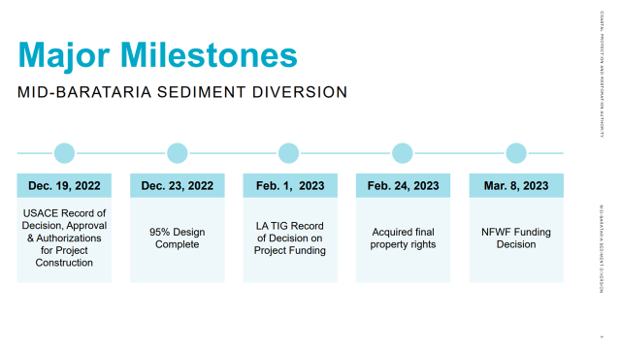

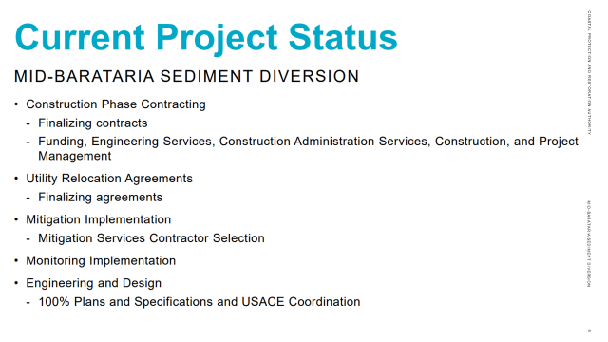

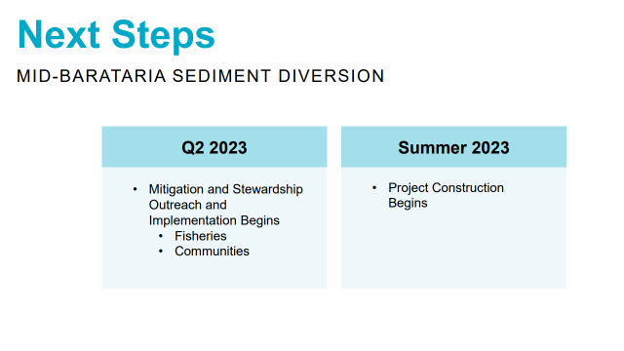

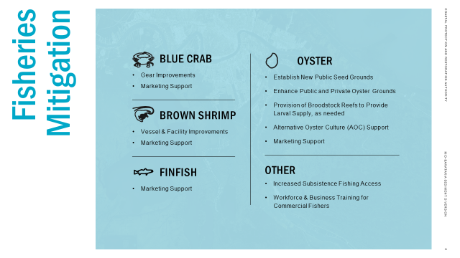

Ben Graham asked what was the rough anticipated completion date? Brian Lezina stated that it should be 5 years minimum

Daniel Edgar stated that he was concerned with the wetlands law, if you take so much wetlands you have to return so much back- there is nothing like that for water, we are going to take brackish water out of the system, there is no mitigation for water habitat, also inquired about having seafood industry members/ local community members sit on the board that determines opening/ closing the gates of this project

James Pelas expressed concern with digging these spillways

Ben Graham requested clarification on the process for those making an application on economic assistance coming down

1. BOEM provided a presentation on the Offshore Wind Development in the Gulf

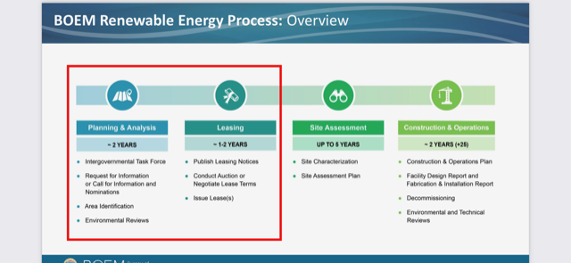

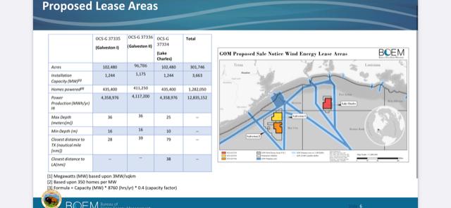

James Pelas asked for feedback on any studies done on the impacts to wildlife; would like receive feedback on the impacts on marine life, BOEM representative stated that they do have a study from oil and gas, data put together that has less conflict to the fisheries, were given 13 possible areas and from these 2 were chosen

Daniel Edgar asked what the fishing restrictions close to the turbines? No restrictions as of now

Still working on mitigation in the instance of a hurricane

1. Moved to the next meeting

**VI.** Public Comment-

Jack Isaacs stated that open access survey for the redfish management options is open on the LDWF website, response rate for the redfish survey is around 3000, lower than seatrout survey but results should be interesting, closing survey in early April, hope to have some results to present by the next meeting

David Cresson stated that what is the timing on potential action on redfish? Once the survey results are in, they will be presented to the LDWF Commission and will get their guidance on moving forward

**VII.** Daniel Edgar requested that pompano be added to the agenda for discussion at the next meeting, how is the fishery set up, quota, what kind of landings do we have, general update

**VIII.** The next Finfish Task Force meeting set for June 15 for 10:00am at LDWF Headquarters in Baton Rouge

**IX.** Daniel Edgar motioned to adjourn the meeting, 2nd by Steve Rockwieler. Motion carries.